CA-2 727721euit179
VINOTH KANNA J
1.
package com.test.CA_2;

import org.openqa.selenium.By;
import org.openqa.selenium.WebDriver;
import org.openqa.selenium.chrome.ChromeDriver;
import org.openqa.selenium.chrome.ChromeOptions;
import org.testng.annotations.BeforeMethod;
import org.testng.annotations.Test;

import io.github.bonigarcia.wdm.WebDriverManager;

public class CA_2_1 {
WebDriver driver;
@Test
public void test() throws InterruptedException
{

}
@BeforeMethod
public void beforeMethod() throws InterruptedException
{
ChromeOptions co=new ChromeOptions();
co.addArguments("--remote-allow-origins=*");
WebDriverManager.chromedriver().setup();
driver=new ChromeDriver(co);
driver.manage().window().maximize();
driver.get("https://www.trivago.in/");
System.out.println("trivago");
String currentTitle=driver.getTitle();
System.out.println(currentTitle);
String expectedTitle="Deals from your favorite bookings sites.";
if(currentTitle.equals(expectedTitle)) {
System.out.println("TITLE DOES NOT MATCH");
}
else {
System.out.println("TITLE MATCH");
}
driver.findElement(By.xpath("//*[@id=\"__next\"]/div[1]/div[1]/section/div[2]/div[3]/div/div[1]/div/form/div[1]")).click();
driver.findElement(By.xpath("/html/body/div[1]/div[1]/div[1]/section/div[2]/div[3]/div/div[1]/div/form/div[2]/ul/li[4]/div/div")).click();
String loc=driver.getTitle();
System.out.println(loc);
String loc1="Kodaikanal.";
if(loc.equals(loc1)) {
System.out.println("LOCATION NOT VERIFIED");
}
else {
System.out.println("LOCATION VERIFIED");
}
driver.findElement(By.xpath("//*[@id=\"__next\"]/div[1]/div[1]/section/div[2]/div[3]/div/div[2]/div/div/div/div[2]/div/div[2]/div[2]/button[15]/time")).click();
driver.findElement(By.xpath("//*[@id=\"__next\"]/div[1]/div[1]/section/div[2]/div[3]/div/div[2]/div/div/div/div[2]/div/div[2]/div[2]/button[20]/time")).click();
String date=driver.getTitle();
System.out.println(date);
String date1="30/04/2023";
if(date.equals(date1)) {
System.out.println("DATES ARE NOT VERIFIED");
}
else {
System.out.println("DATES ARE VERIFIED");
}
driver.findElement(By.xpath("/html/body/div[1]/div[1]/div[1]/section/div[2]/div[3]/div/div[2]/div/div/div[1]/div/div[1]/div[2]/div/button[2]")).click();
driver.findElement(By.xpath("/html/body/div[1]/div[1]/div[1]/section/div[2]/div[3]/div/div[2]/div/div/div[1]/div/div[1]/div[2]/div/button[2]/span/span[1]")).click();
driver.findElement(By.xpath("/html/body/div[1]/div[1]/div[1]/section/div[2]/div[3]/div/div[2]/div/div/div[2]/div/button[2]")).click();
driver.findElement(By.xpath("/html/body/div[1]/div[1]/div[1]/section/div[2]/div[3]/div/button")).click();

String pet=driver.getTitle();
System.out.println(pet);
String pet1="pet friendly";
if(pet.equals(pet1)) {
System.out.println("PET FRIENDLY IS NOT VERIFIED");
}
else {
System.out.println("PET FRIENDLY IS VERIFIED");
}
driver.findElement(By.xpath("/html/body/div[1]/div[1]/div[1]/section/div[2]/div[3]/div/button")).click();
}
}

Reports:
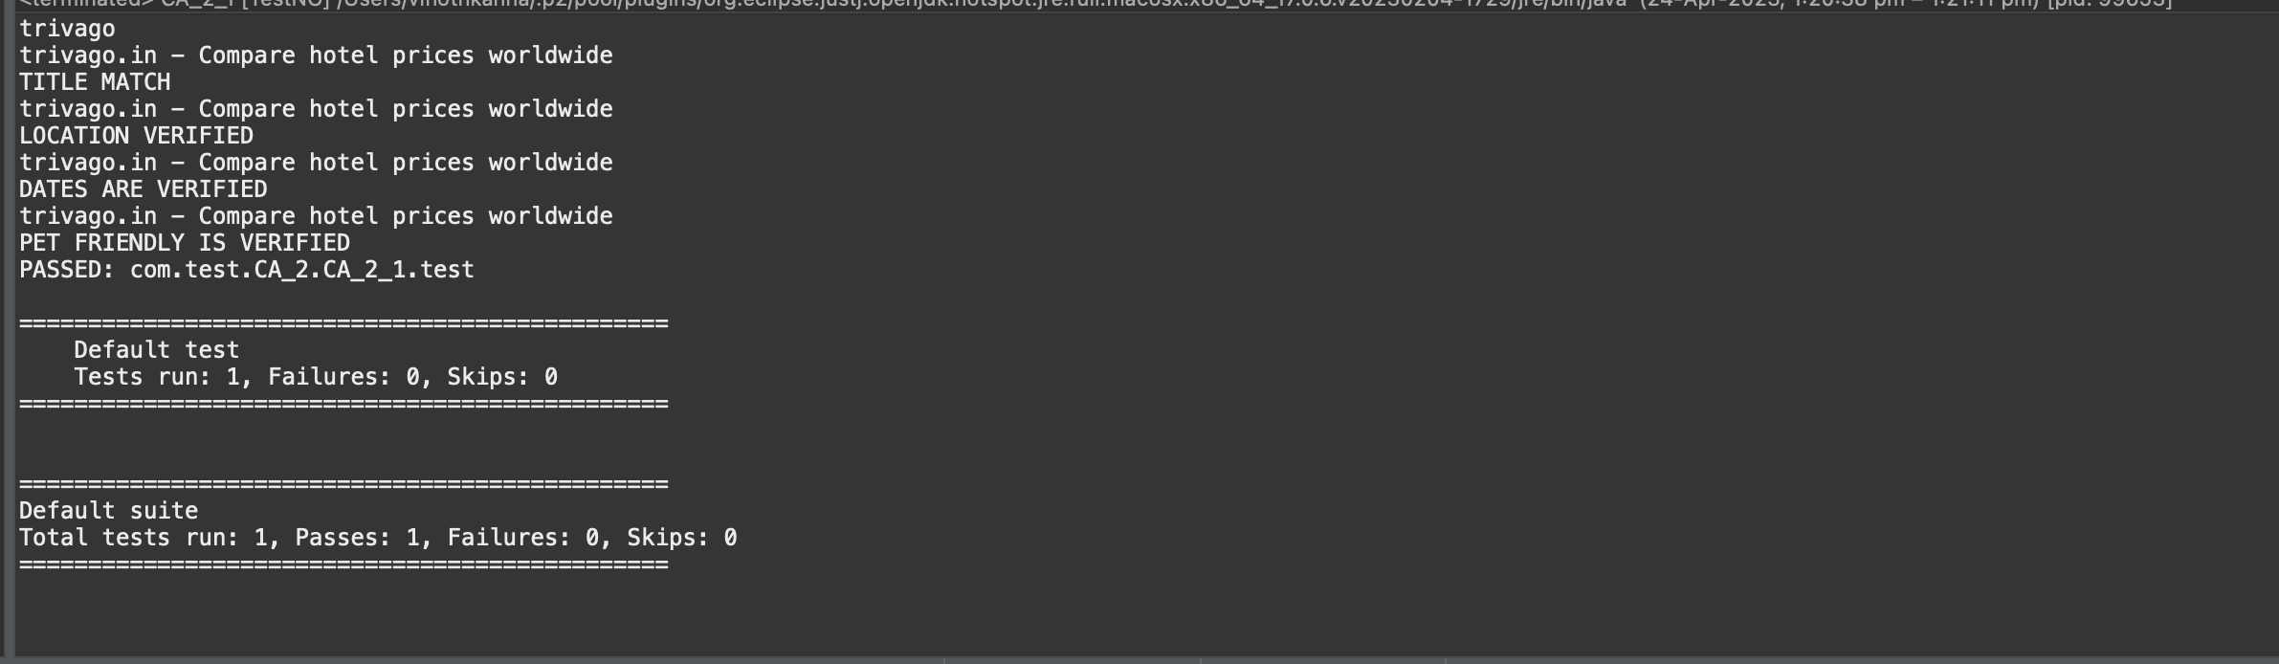

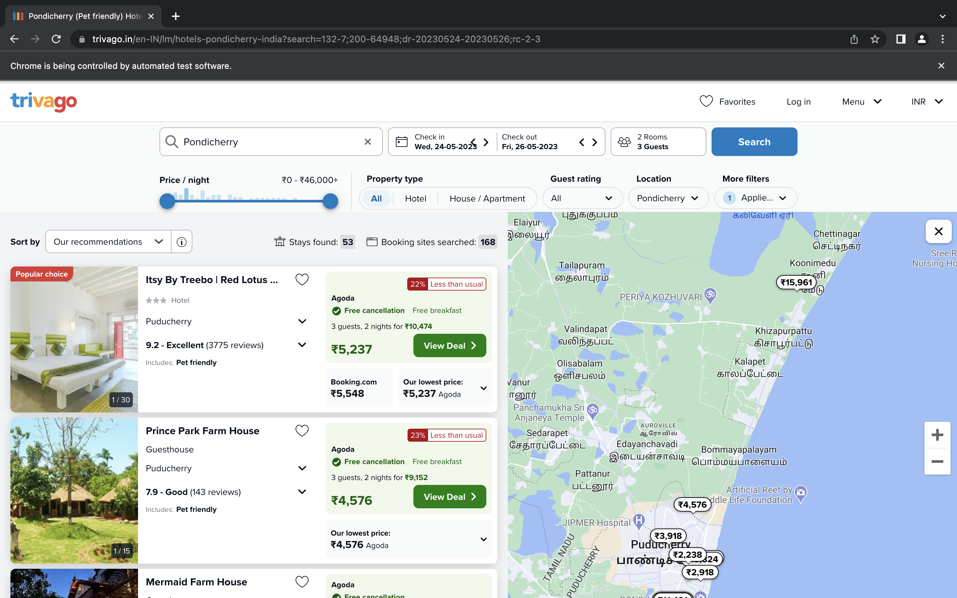

2.

package Question1;
import java.util.List;
import org.openqa.selenium.By;
import org.openqa.selenium.WebDriver;
import org.openqa.selenium.WebElement;
import org.openqa.selenium.chrome.ChromeDriver;
import org.openqa.selenium.chrome.ChromeOptions;
import org.openqa.selenium.support.ui.Select;
import org.testng.annotations.Test;
import io.github.bonigarcia.wdm.WebDriverManager;
public class Question2 {
WebDriver driver;
@Test(priority=1)
public void Mandatory() throws InterruptedException {
ChromeOptions co=new ChromeOptions();
co.addArguments("--remote-allow-origins=*"); WebDriverManager.chromedriver().setup(); driver=new ChromeDriver(co);
driver.navigate().to("
https://www.trivago.in/en-IN/lm/hotels-pondicherry-india?search=101-2;101-5;10
1-53;101-6;101-9;200-64948;dr-20230501-20230506");
driver.manage().window().maximize(); Thread.sleep(35000); System.out.println(driver.getTitle());
driver.findElement(By.xpath("//button[@data-testid=\"search-button\"]")).click ();
}
@Test(priority=2) public void tc01() {
Select select=new Select(driver.findElement(By.xpath("//select[@id=\"sorting-selector\"]")));
select.selectByIndex(3);
} @Test(priority=3)
public void tc02() {
System.out.println(driver.findElements(By.xpath("//button[@data-testid=\"item- name\"]")).get(0).getText()+" ");
} @Test(priority=4)
public void tc03() throws InterruptedException {
Select select=new
Select(driver.findElement(By.xpath("//select[@id=\"sorting-selector\"]"))); select.selectByIndex(1);
Thread.sleep(3000);
} @Test(priority=5)
public void tc04() {
List<WebElement> names=driver.findElements(By.xpath("//button[@data-testid=\"item-name\"]/span" ));
}
for(WebElement ele:names) System.out.print(ele.getText()+" ");
System.out.println();
@Test(priority=6) public void tc05() {
System.out.println("Stays found : "+driver.findElement(By.xpath("//*[@id=\"__next\"]/div[1]/main/div[5]/div[3]/d iv/div[2]/div[1]/div/div[2]/div[2]/div/div/div[1]/span[2]/strong")).getText()) ;
} @Test(priority=7)
public void tc06() {
System.out.println("Booking sites reached: "+driver.findElement(By.xpath(" //*[@id=\"__next\"]/div[1]/main/div[5]/div[3]/div/div[2]/div[1]/div/div[2]/div [2]/div/div/div[2]/span[2]/strong\n")).getText());
} }

OUTPUT:
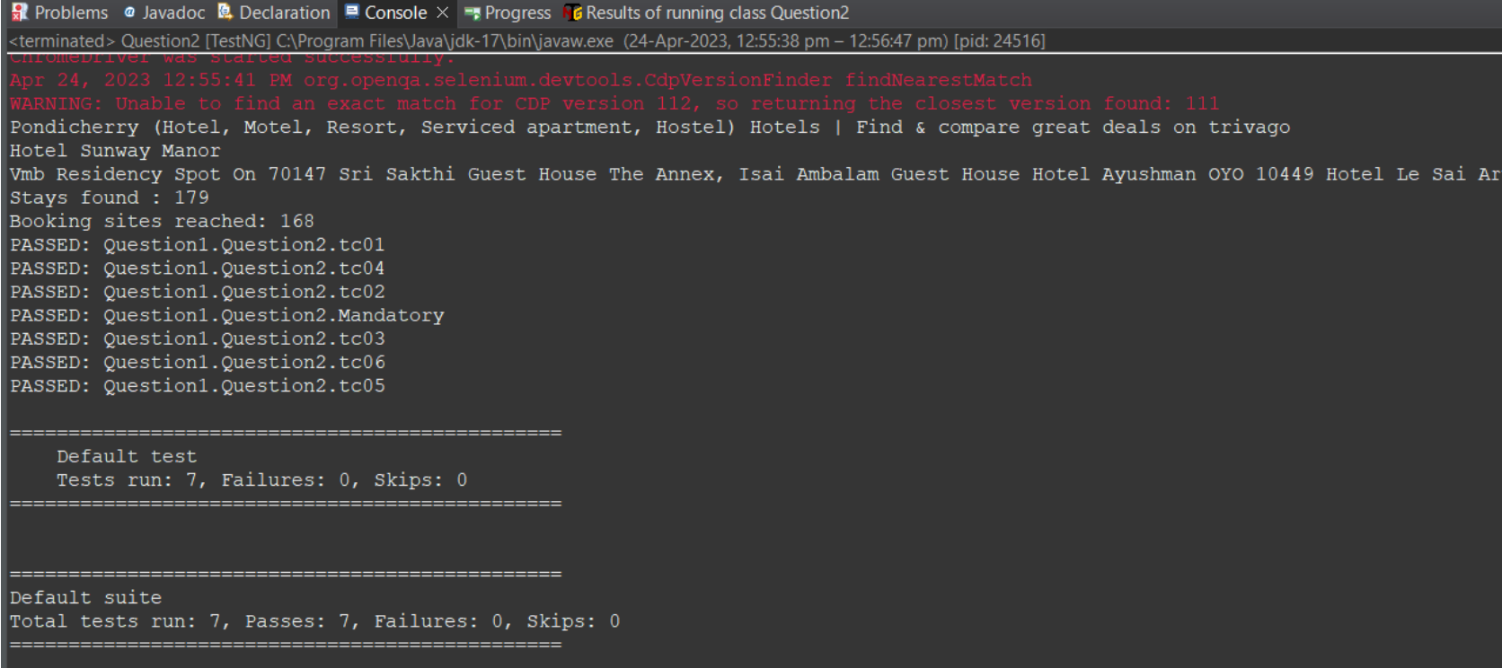

3.

CODE:
package Question1;
import java.util.List;
import org.openqa.selenium.By;
import org.openqa.selenium.WebDriver;
import org.openqa.selenium.WebElement;
import org.openqa.selenium.chrome.ChromeDriver;
import org.openqa.selenium.chrome.ChromeOptions;
import org.testng.annotations.Test;
import io.github.bonigarcia.wdm.WebDriverManager;
public class Question3 {
WebDriver driver;
@Test(priority=1)
public void Mandatory() throws InterruptedException {
ChromeOptions co=new ChromeOptions();
co.addArguments("--remote-allow-origins=*"); WebDriverManager.chromedriver().setup(); driver=new ChromeDriver(co);
driver.navigate().to("
https://www.trivago.in/en-IN/lm/hotels-pondicherry-india?search=101-2;101-5;10
1-53;101-6;101-9;200-64948;dr-20230501-20230506");
driver.manage().window().maximize(); Thread.sleep(35000); System.out.println(driver.getTitle());
driver.findElement(By.xpath("//button[@data-testid=\"search-button\"]")).click ();
}
@Test(priority=2) public void tc01() {
List<WebElement> names=driver.findElements(By.xpath("//button[@data-testid=\"item-name\"]/span" ));
for(int i=0;i<5;i++) System.out.println(names.get(i).getText()+" ");
System.out.println(); }
@Test(priority=3)
public void tc02() throws InterruptedException {
driver.findElement(By.xpath("//*[@id=\"__next\"]/div[1]/main/div[5]/section/di v/div/ol/li[1]/div/article/div[2]/div[2]/div[1]/div/div[3]/div[2]/button")).cl ick();
Thread.sleep(5000);
System.out.println(driver.getTitle()); }
@Test(priority=4) public void tc03() {
System.out.println("Price : "+driver.findElement(By.xpath("//*[@id=\"contentContainer\"]/div[3]/ol/li[1]/d iv[2]/a/div/div[3]/div/div[2]/aside[2]/ul/li[2]/div/span[3]")).getText());
}
@Test(priority=5)
public void tc04() throws InterruptedException {
driver.findElement(By.xpath("//*[@id=\"contentContainer\"]/div[3]/ol/li[1]/div [2]/a/div/div[3]/div/div[3]/button")).click();
Thread.sleep(5); }
@Test(priority=6) public void tc05() {
driver.findElement(By.xpath("//*[@id=\"ChildRoom-CiII6OyUxQQQAiDiAyi4x5ANMARKC zFEMTAwUF8xMDBQUJgFEgYIASICBGwaBCgEMAE=\"]/div/div[4]/div[2]/div/div[1]/button ")).click();
}
@Test(priority=7) public void tc06() {
driver.findElement(By.xpath("//input[@title=\"Please enter first name\”]")).sendKeys("Vinoth Kanna");
driver.findElement(By.xpath("//input[@title=\"Please enter a valid email address so we can send you your booking
confirmation.\”]")).sendKeys("vinothkanna@gmail.com");
driver.findElement(By.xpath("//input[@title=\"Please make sure the “Email” and “Retype email” fields
match.\"]")).sendKeys("vinothkanna@gmail.com");
}
@Test(priority=8) public void tc07() {
System.out.println(driver.findElement(By.xpath("//*[@id=\"SiteContent\"]/div/d iv[2]/div[2]/div[2]/div[1]/h4/span[1]")).getText()+"- "+driver.findElement(By.xpath("//*[@id=\"SiteContent\"]/div/div[2]/div[2]/div[ 2]/div[1]/h4/span[2]")).getText());
}

OUTPUT:

